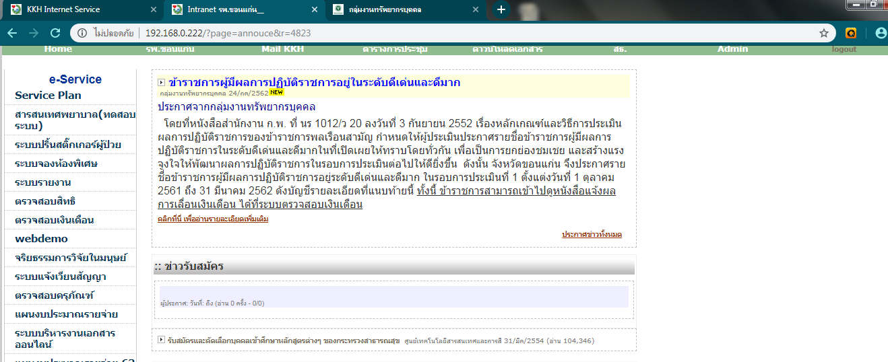

http://192.168.0.222/downloads/documents/20190724154835_ff.pdf

